Aditya Bhujle

1 – 3: Group 4-6: My work

1. Roommate app

Scheduling for roommate chores

Ex. Every friday it will remind one roommate to throw out the trash.

Will alert other roommates if a chore is not done or if it is done

**Persona 1** James, age 21 is in college finishing his Junior year. He grew up in North Carolina for most of his life and enjoys working on cars in his spare time. His father is an engineer and his mother is a teacher. He is working towards a degree in finance.

James likes to use software that simplifies tasks and makes everyday life more efficient. Cleanliness is a priority which has been an issue with some of his previous roommates. Even after speaking to these roommates on multiple occasions things are still not cleaned and he doesn’t want to keep asking. Creating an app to send all roommates notifications to clean on respective days would be a solution to this problem.

**Persona 2** Robert , age 18. Robert is a sophomore, who grew up in Idaho and moved to North Carolina for school. In his spare time he enjoys cooking, reading, hanging out with his friends. Robert is majoring in french.

He likes to cook but never to clean, he always leaves the kitchen a mess and not clean it after he uses it, the house chores are shared but Robert never does his part, his roommates have to ask him over and over to clean and do his part. So now they are creating an App to help them do the house Chores to keep the house clean.

1. A stakeholder of this project would be the landlord who owns the property. The landlord is indirectly benefiting as this app makes sure that roommates are completing their responsibilities on time, which avoids neglect and ensures that the property is properly maintained.
2. Ask an Expert (Who you are and your applicable skills/experiences)

**Seth Close:**

I am a Senior majoring in AI and robotics that is currently working to get experience in robotic design and implementation. I have experience in product and user interface design with mobile device applications, custom prosthetics, as well as devices that test equipment. These experiences have helped me to understand what the user will think and expect from our future product.

**John Iannacone**

I have experience in application design for a social teaching platform and hope to work in systems integration after I graduate in the fall. I have a lot of experience in group collaboration and public speaking/presentation.

**Aditya Bhujle:**

Application Programming

Applicable Skills: Built a few websites and apps in JavaScript and Python. Have experience in state management from frameworks like React and Angular.

**Shail Shah:**

I am a junior in Computer Science with concentration in Cyber Security. I will graduate in summer of 2021. I have experience in programming robots in Python. I have experience with networking and security. I also have experience with customer service and handling customer complaints.

**Louise Diouf**

I’m a senior graduating in December 2020 with a double major in Computer Information Technology and french and english/French translation certificate. I work in customer service in our family business and also work as an interpreter at Presbyterian Hospital.

Have some experience in designing an application, interface, prototyping.

4)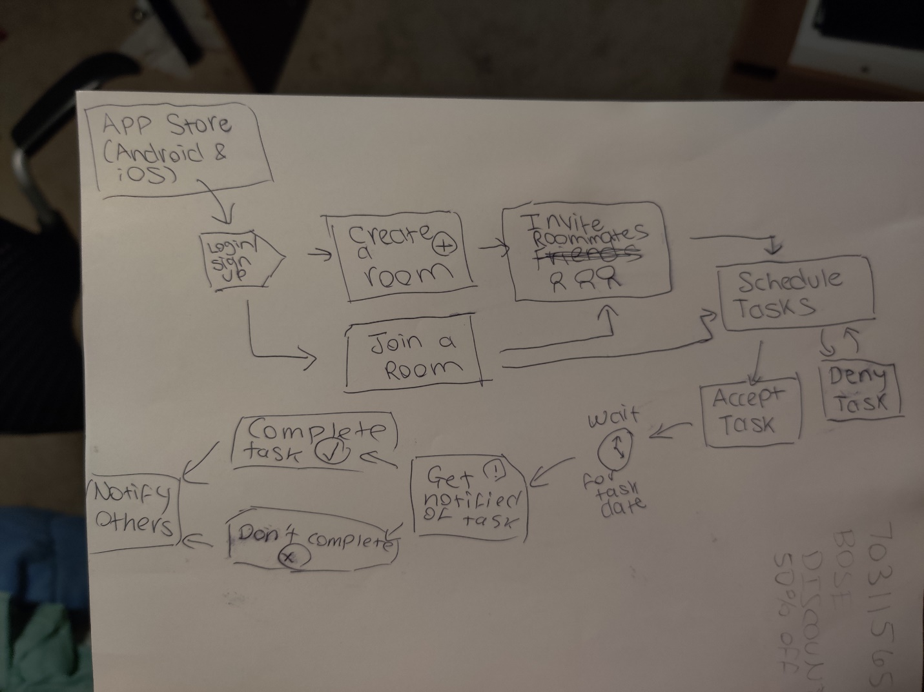

5)

It's Friday, the day that James' apartment does their chores. James is finishing a day of work and comes home to messy dishes and a full garbage can. He feels frustrated and annoyed that even though he ensured all his chores are complete, his roomates didn't do the same. They constantly forget to do their chores, and James doesn't have the time nor energy to text them every time a chore needs to be done.

Enough is enough. James installs our app, Roommates, and signs up. He creates a room and invites all his roommates. They join the room. He then schedules the room with their chores and assign them to his roomates. Most roommates accept them. However, James has made an error on one of the tasks assigned to his roommate Joel, who denies the initial request, modifies it and accepts it. After everyone is happy with the requests, they move on to other things and forget about the app.

Fast forward to next Friday where each of the roommates get notifications on what they need to get done. After completing their chores, they each check off that it is completed in the app. At work, James recieves 4 new notifications about how his roomates have completed their chores.

6)

Features List:

Log in/Sign up Feature

Main Login Support: Google and Facebook

Standard email/password as default

Share Feature for inviting roommates:

Utilizes iOS and Android OS's share features:

This gives dedicated support to all messaging including Snapchat, GroupMe, WhatsApp, Texting etc.

Schedule Tasks

Utilizing iOS and Android's native calendar popup and syncing with Google Calendar by integrating Google's Calendar API

Push Notifications

Send out push notifications for any major event that roommates may need to know:

If roommate accepted or denied their chore schedule

If roommate completed or forgot about a chore